Circuit Designing And Implementation Workshop

Reported By: CEPCO Group

Group Candidates Are:

1. S. Siva Kumar
2. C. Santosh
3. Ahmed Abdulrahman Abdullah Bin Alfaqeeh

Reported ON: 25/5/2024

**Simulation Results:**

1. LED ON –OFF:
2. Description of the simulation:  
   we have implemented LED on-off using Tinkercad. The circuit consists of the following components:
3. Power Supply: Set to provide 5.00 V.
4. Green LED: Indicates the presence of current flow.
5. 1kΩ Resistor: Limits the current to prevent damage to the LED.
6. Slide Switch: Controls the connection, allowing the circuit to be opened or closed.

When the simulation is running, the power supply provides a constant 5.00 V to the circuit. The resistor is placed in series with the green LED to limit the current flowing through the LED, protecting it from excessive current that could cause damage. The slide switch, when closed, completes the circuit, allowing current to flow from the power supply, through the resistor and LED, and back to the ground. This current flow causes the LED to emit light, indicating that the circuit is active. The ammeter shows a current of 3.11 mA, confirming the proper operation of the circuit

1. 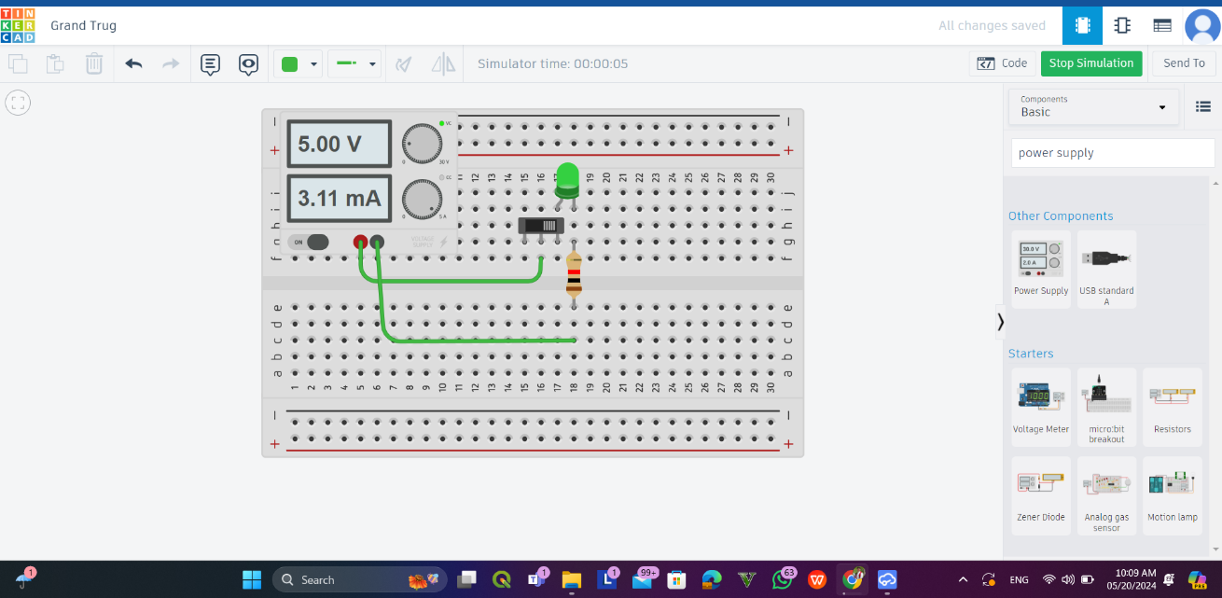TinkerCad pictures(circuit layout-schematic diagram-components) :

1.Circuit layout

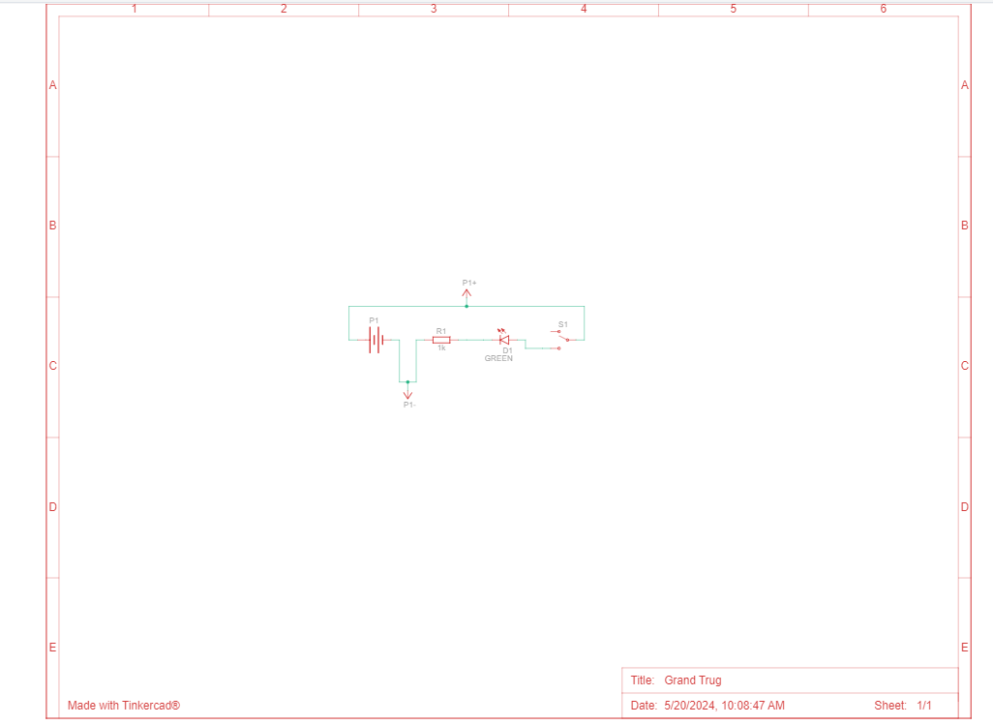

2.Schematic diagram



3.Components

1. Transient Response:  
   The transient response occurs when the slide switch is toggled. Closing the switch completes the circuit, causing the LED to light up almost instantaneously. Opening the switch breaks the circuit, causing the LED to turn off immediately
2. Half Adder:
3. Description of the simulation:  
   The half-adder circuit displayed uses a breadboard setup with key components including the 74HC86 (quad XOR gate) and 74HC08 (quad AND gate) ICs, powered by a 5V supply. The inputs are connected to these gates, with the XOR gate producing the sum output and the AND gate producing the carry output. Resistors (1kΩ) are used with red and green LEDs to visually indicate the sum and carry states. The schematic shows these connections clearly, with the power supply ensuring all components are powered correctly. The transient response of this circuit involves the outputs reacting to changes in the input signals, with the XOR gate lighting up the red LED for the sum and the AND gate lighting up the green LED for the carry when both inputs are high. The current measurement of 3.01mA indicates a typical operation for the LEDs. The circuit’s propagation delay and potential brief glitches during input transitions are inherent characteristics of digital logic gates. The breadboard layout faithfully follows the schematic, ensuring correct implementation and predictable transient behavior.
4. 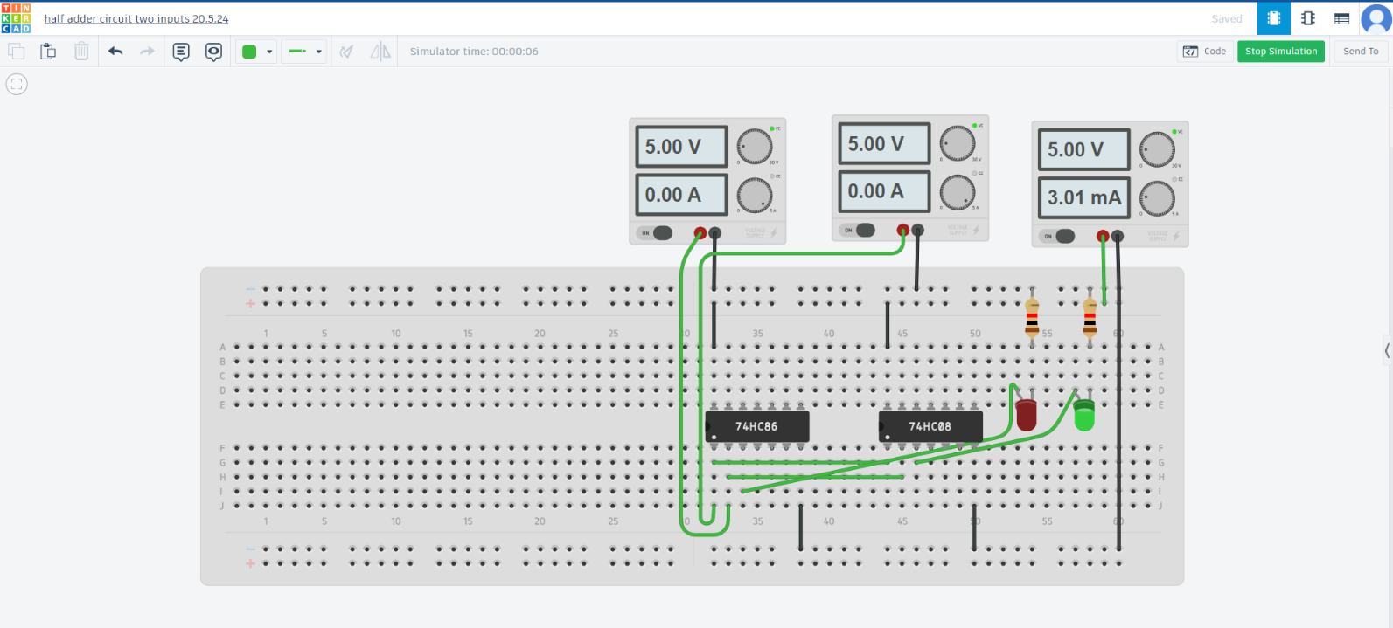TinkerCad pictures(circuit layout-schematic diagram-components):  
     
     
     
     
     
     
     
     
     
     
     
     
     
   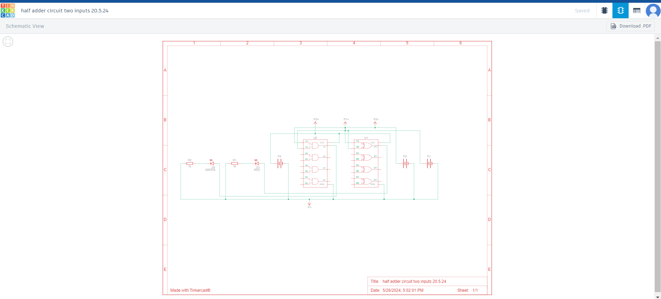

1.Circuit layout

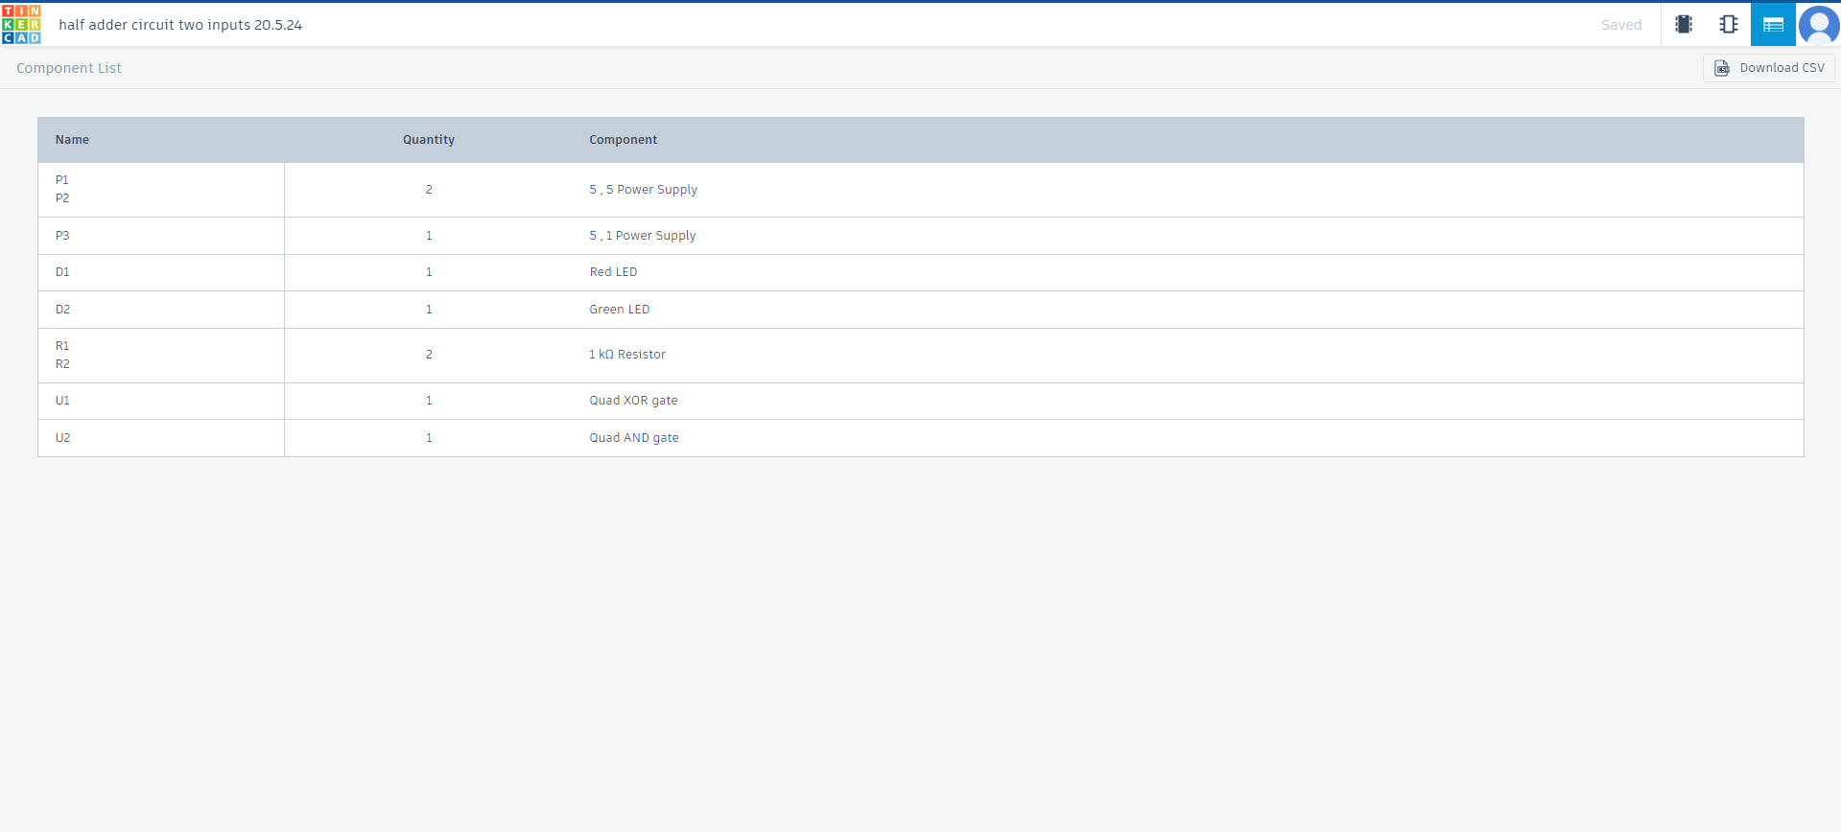

3.Components

2.Schematic diagram

1. Transient Response:

During switching events from one state to another. For a half-adder circuit:

1. Sum Output (XOR Gate Output): When the inputs change, the XOR gate will produce a sum output based on the exclusive OR logic. The LED connected to this output will light up accordingly.
2. Carry Output (AND Gate Output): When both inputs are high, the AND gate will produce a carry output. The LED connected to this output will light up when both inputs are 1.
3. Propagation Delay: There will be a slight delay from when the inputs change to when the outputs stabilize, typically on the order of nanoseconds for CMOS logic gates like the 74HC series.  
   Glitches/Spikes: Due to the nature of digital circuits, especially during input transitions, brief glitches or spikes might appear at the output, particularly if the inputs change simultaneously but not exactly at the same time.
4. 555IC:
5. Description of the simulation:  
   The circuit is designed to blink an LED using a 555 timer IC in a stable mode. The schematic shows a 555 timer (U1) with a configuration that includes resistors R1 (16kΩ) and R2 (6.8kΩ), a capacitor C1 (10µF), and an LED (D1) connected through a 220Ω resistor (R3). The power supply (P1) is set to 6.3V. In this configuration, the 555 timer oscillates, creating a square wave output at pin 3. The oscillation frequency and duty cycle are determined by R1, R2, and C1. When the output at pin 3 goes high, the LED lights up, and when it goes low, the LED turns off, causing it to blink. The breadboard setup matches the schematic with accurate connections. The measured voltage is 6.3V, and the current is 6.35mA, indicating the circuit operates correctly. The transient response involves the charging and discharging cycles of C1, causing periodic switching of the output, resulting in the LED blinking.
6. 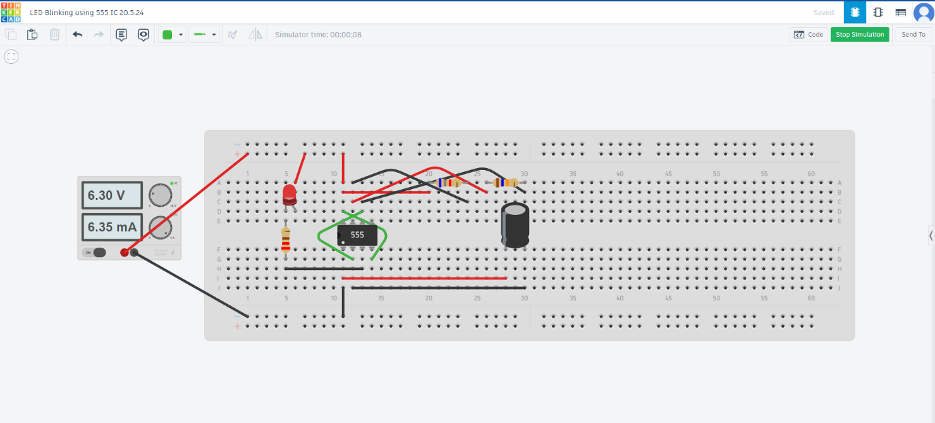TinkerCad pictures(circuit layout-schematic diagram-components):

1.Circuit layout

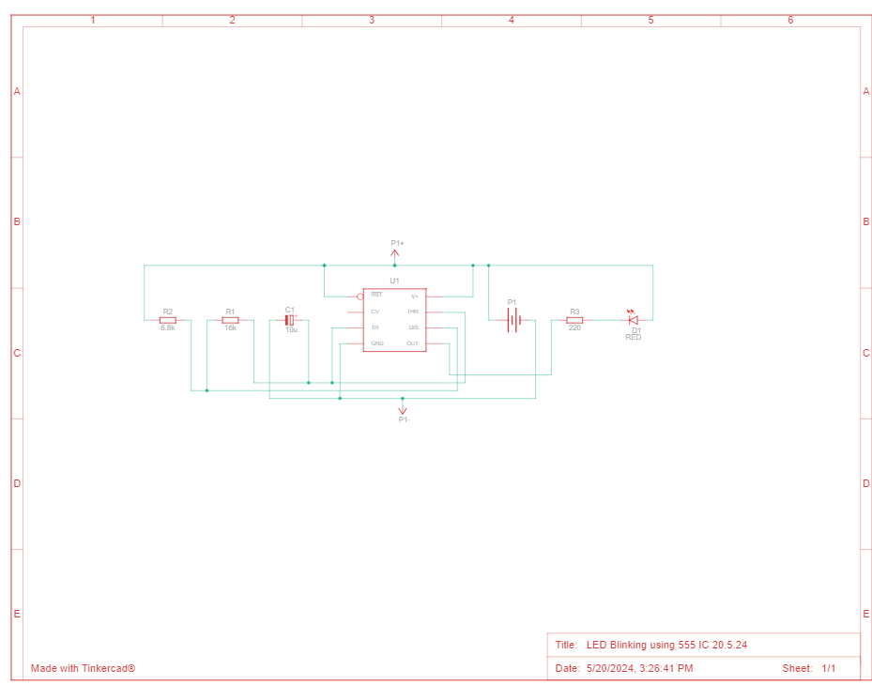

2.Schematic diagram



3.Components

1. Frequency Observation:  
   The LED blinking frequency in the 555 timer circuit is determined by the charging and discharging cycles of the capacitor 𝐶1C1. The 555 timer switches its output between high and low states based on the voltage thresholds of 2/3 and 1/3 of the supply voltage. During the high state, the LED lights up, and during the low state, the LED turns off. The duration of these states, and thus the blinking frequency, is controlled by the resistors 𝑅1R1 and 𝑅2R2 and the capacitor 𝐶1C1, resulting in a continuous, periodic blinking of the LED.
2. Transient Response:  
   The transient response of the LED blinking circuit using the 555 timer IC involves the capacitor 𝐶1C1 charging through resistors 𝑅1R1 and 𝑅2R2. As 𝐶1C1 charges, its voltage rises until it reaches a threshold, causing the 555 timer to switch states, turning the output at pin 3 low and starting the capacitor's discharge through 𝑅2R2. During charging, the LED is on; during discharging, the LED is off. This cycle of charging and discharging causes the LED to blink on and off.

The repeated charging and discharging of the capacitor create a periodic oscillation, with the LED blinking at a rate determined by the resistor and capacitor values. This demonstrates the transient response of the 555 timer in astable mode, where it continuously switches states without external triggers, showing how the circuit responds over time to the power supply, leading to the steady blinking of the LED.

1. Student Task1:Analog:Police light using 555IC:
2. Description of the simulation:  
   The police light circuit works by using a 555 timer IC in a stable mode to create a continuous oscillation, which alternates between high and low output states, causing two LEDs (red and blue) to blink alternately. When powered on, the capacitor 𝐶1C1 starts charging through resistors 𝑅1R1 and 𝑅2R2. As the capacitor voltage reaches 2/3 of the supply voltage, the 555 timer changes state, causing the output pin (pin 3) to go low and the capacitor to discharge through 𝑅3R3. During the charging phase, the red LED (D1) is lit, and during the discharging phase, the blue LED (D2) is lit. Once the capacitor discharges to 1/3 of the supply voltage, the 555 timer switches states again, causing the output to go high and restarting the cycle. This cycle repeats indefinitely, with the timing of the oscillation determined by the values of the resistors and the capacitor, resulting in the LEDs flashing alternately and creating a police light effect.
3. TinkerCad pictures(circuit layout-schematic diagram-components):

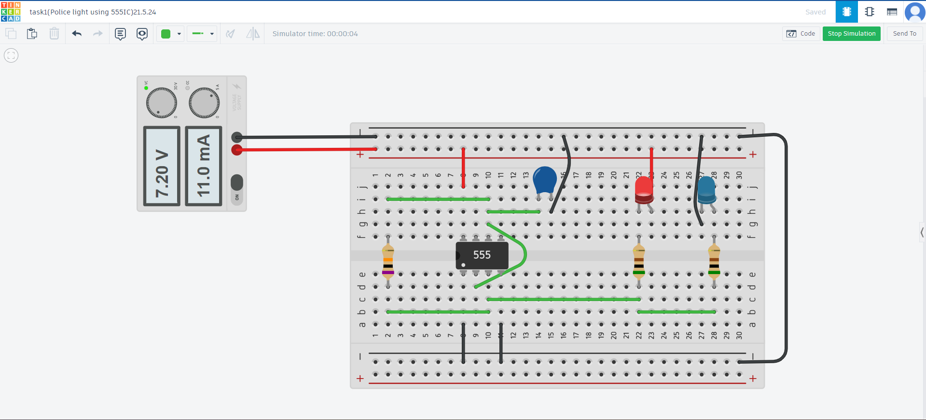

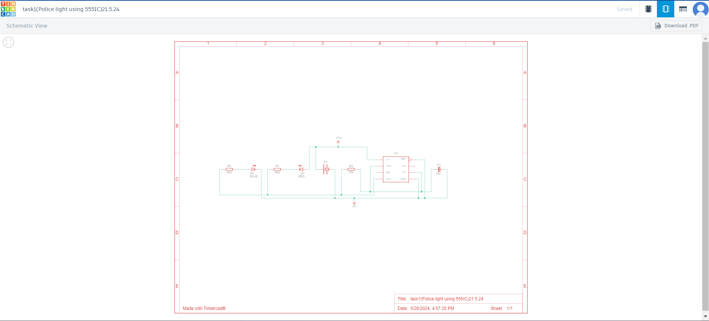

1.Circuit layout

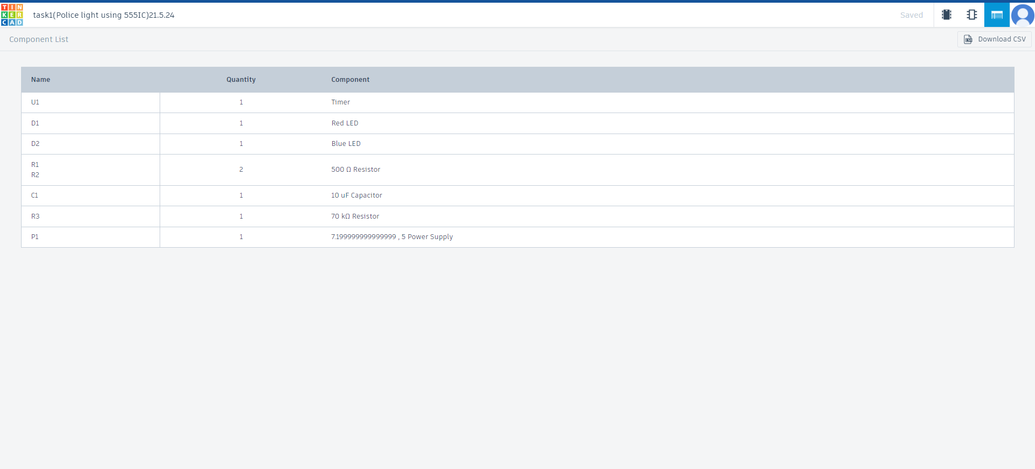

3.Components

2.Schematic diagram

1. Transient Response:   
   The transient response of the circuit involves the capacitor 𝐶1C1 charging through resistors 𝑅1R1 and 𝑅2R2. As the capacitor charges, its voltage increases until it reaches the threshold of the 555 timer, causing the output to switch states. This state change causes the capacitor to discharge through 𝑅3R3, resulting in a low output from the 555 timer and the blue LED lighting up. Once the capacitor discharges to a lower threshold, the 555 timer switches states again, restarting the cycle. This charging and discharging cycle creates a periodic oscillation, resulting in the LEDs alternately flashing. The frequency and duty cycle of the flashing depend on the values of the resistors and the capacitor. The measured voltage and current indicate the circuit is functioning as designed, providing a visual representation of the transient response through the alternating LEDs.
2. Student Task2:Digital: 8-Bit Counter Using J-K Flip Flops and 555 Timer:
   1. Description of the simulation:  
      We did the simulation of an 8-bit counter circuit using J-K flip-flops and a 555-timer IC. The multiple J-K flip-flops (74HC73) are arranged in series to form an 8-bit counter. The 555 timer (U1) generates the clock signal for the flip-flops. Each flip-flop has its J and K inputs tied to the high logic level, configuring them to toggle state on every clock pulse. The output of each flip-flop is connected to LEDs through 560Ω resistors to visually indicate the binary count. The power supply provides 6V to the circuit. The simulation breadboard setup replicates the schematic with accurate connections. The 555 timer is configured to generate a continuous square wave clock signal, visible on the oscilloscope. This clock signal is fed into the clock input of the first J-K flip-flop. Each subsequent flip-flop is clocked by the output of the preceding flip-flop, creating a ripple counter effect. The LEDs connected to the flip-flop outputs light up in a binary counting sequence, demonstrating the 8-bit counter operation.
   2. TinkerCad pictures(circuit layout-schematic diagram-components):

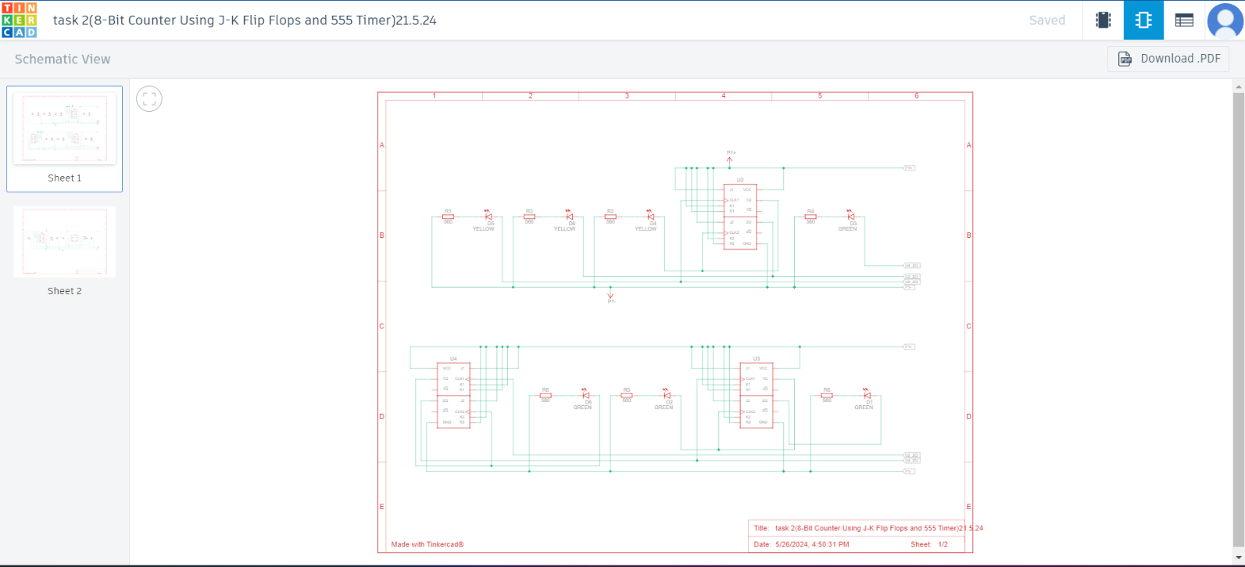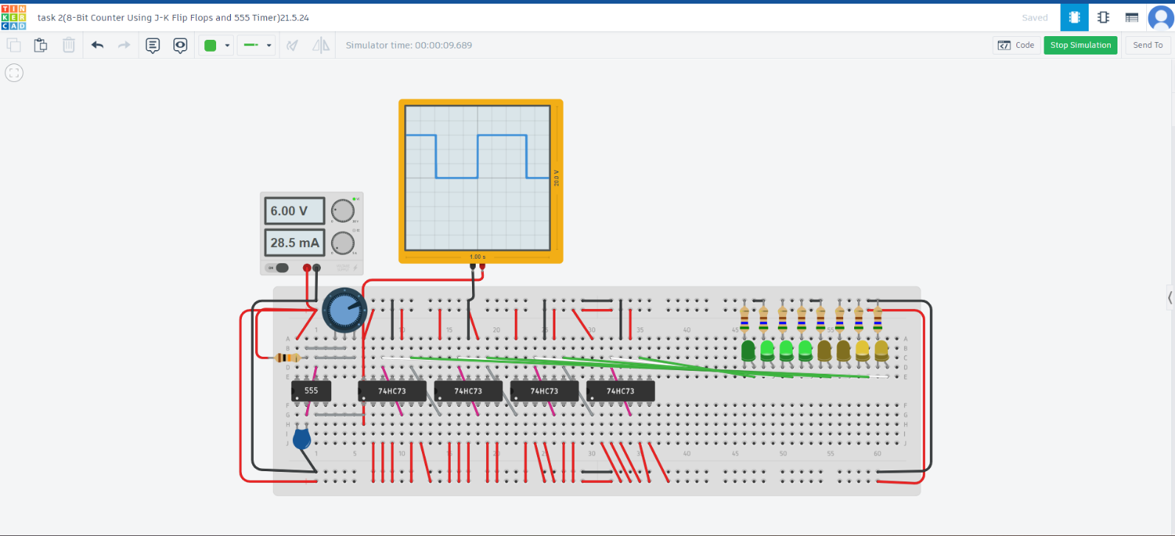  
  
  
  
  
  
  
  
  
  
  
  
  
  
  
  
  
  
  
  
  
  
  
  
  
  
  
  
  
  
  
  
  
  
  
  
  
  
  
  
  
  
  
  
  
  
  
  


2.Schematic diagram

1.Circuit layout

3.Components

* 1. Frequency Observation:  
     The frequency of the clock signal generated by the 555 timer determines the rate at which the counter increments. The timer is set to produce a square wave with a frequency defined by the resistor and capacitor values in its configuration. The frequency is visible on the oscilloscope, showing the time period of the square wave signal.
  2. Transient response:   
     The Transient response of the circuit involves the clock pulses from the 555 timer causing the J-K flip-flops to toggle states. On each rising edge of the clock pulse, the first flip-flop toggles its state, and each subsequent flip-flop toggles when the preceding one changes from high to low. This sequential toggling creates a binary count, which is visually represented by the LEDs. The LEDs switch states in a predictable pattern, showing the transient response of the flip-flops to the clock signal, with each LED representing a bit in the binary count. The overall transient behavior is a smooth, continuous counting sequence driven by the stable clock pulses from the 555 timer.

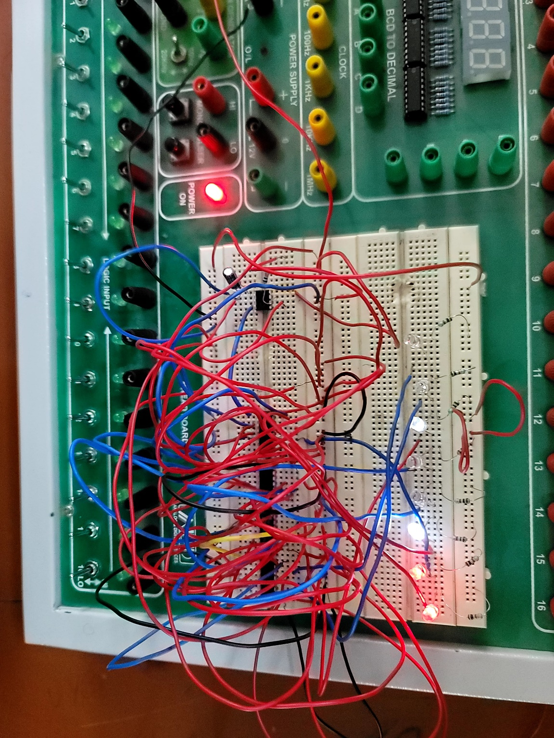

**Hardware Implementation**

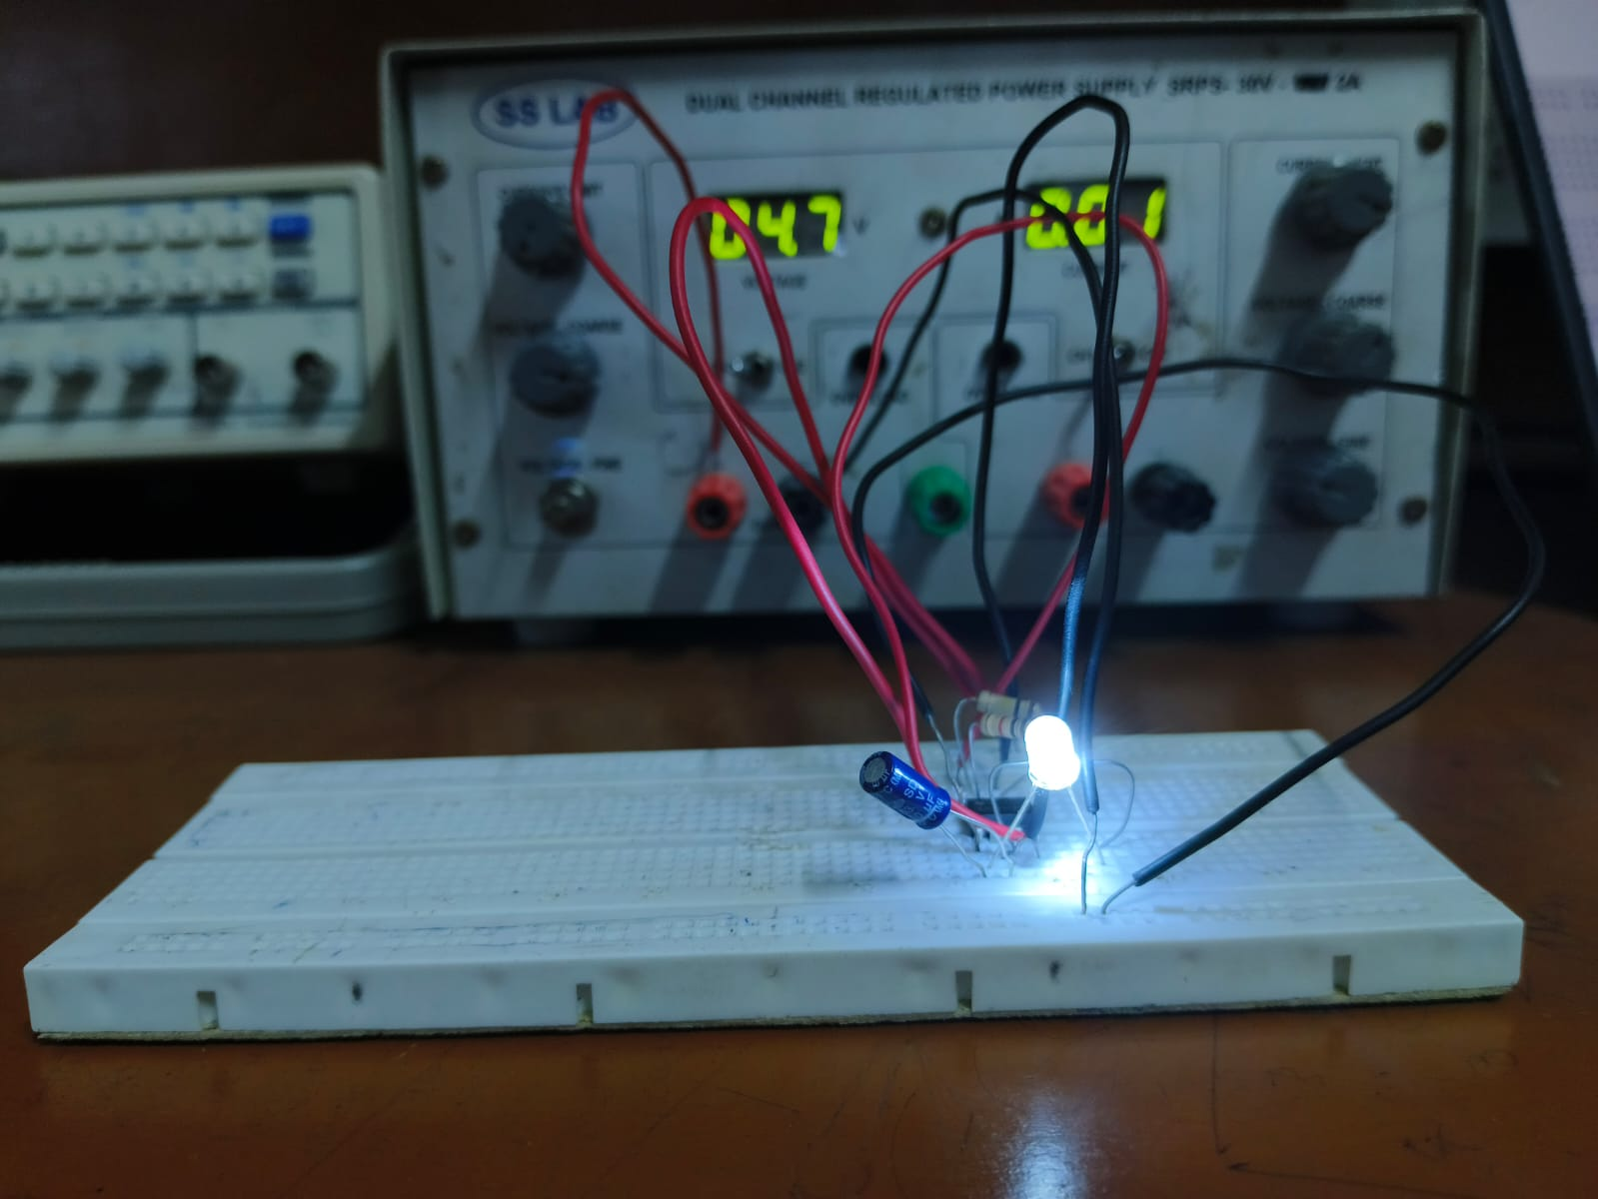



**Comparison of Simulation and Hardware Results:**

|  |  |
| --- | --- |
| Simulation Results | Hardware Results |
| The input voltage was nearly from 5v to 12v maximum | The input voltage was maximum was 5v and 12v could damage the component |
| For 8-bit counter we could maximize the speed too fast | The counter speed was restricted as if we increase the resistance the LEDs won’t glow |
| For police lights the intensity of two LEDs is good enough for 5v | The LEDs glow bit dimmer with same 5v applied for it |
| The connections were simple and easy to connect | Connections were too hard and confusing if there were more junction points |

* As we took 7473 IC (J-K flip flop with clear) in simulation but in hardware we implemented 7476 IC due to lack of availability.
* According to that IC we modified the connections of the circuit.
* For hardware there were more difficulties like loose connections, proper wire placement, etc.
* In simulation the circuit works perfectly if we connect but in hardware there were more challenges like where the problem is.
* We modified the circuit connections as per the breadboard availability and port connections.

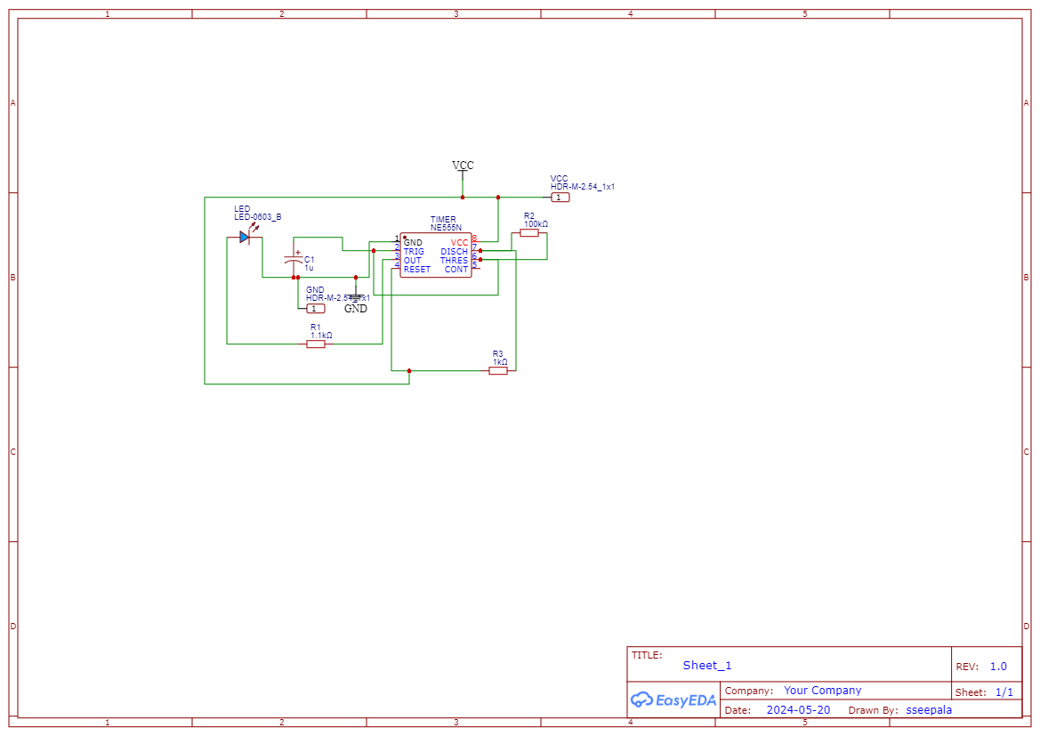**Circuit Building on EasyEDA**

LED Blinking Using Timer

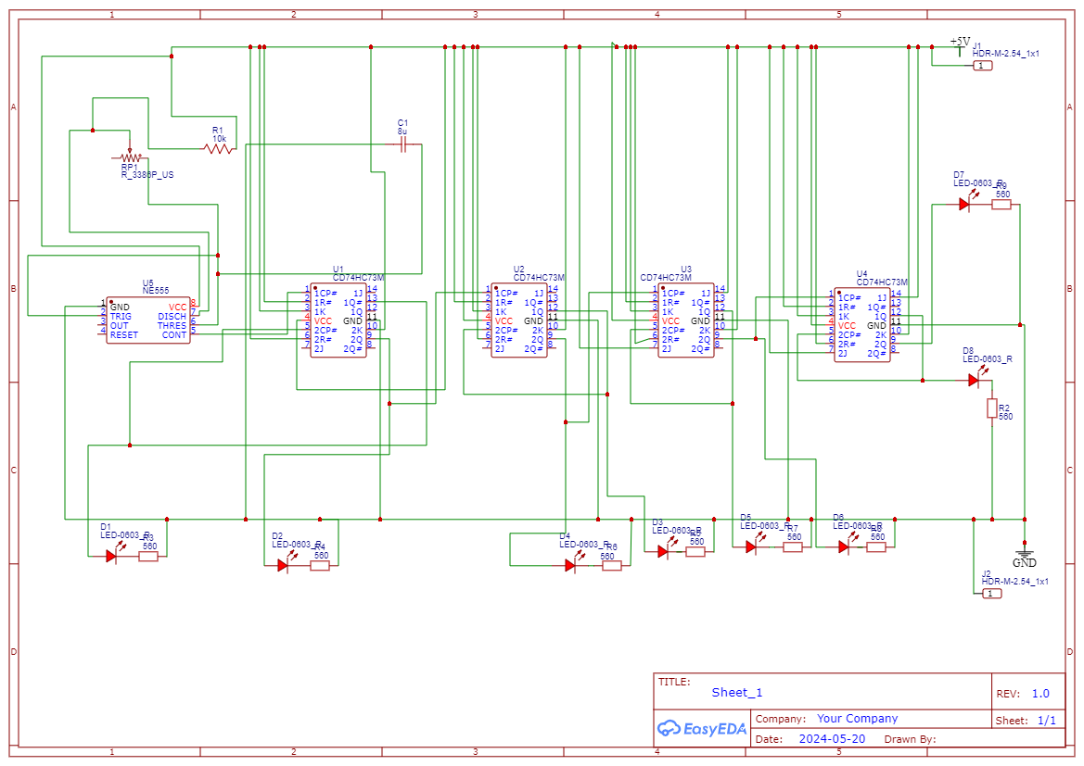

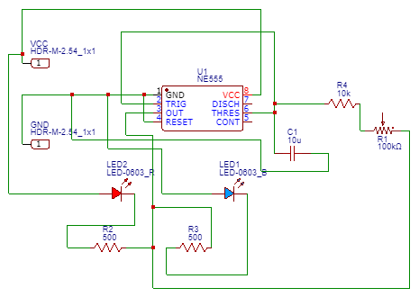8-bit Synchronous Counter

Police Lights Blinking using Timer

**PCB Designing on EasyEDA**

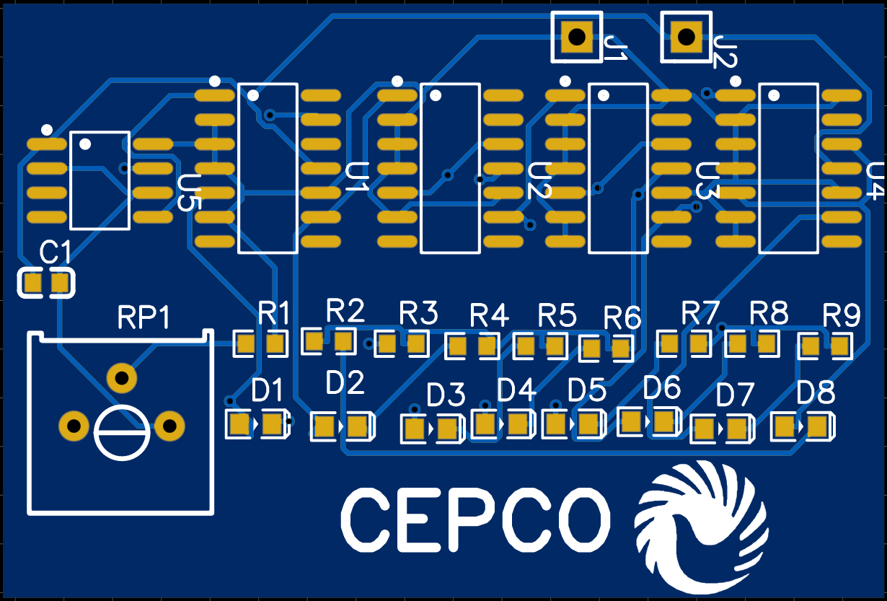

8-Bit Synchronous Counter using J-K flip flop

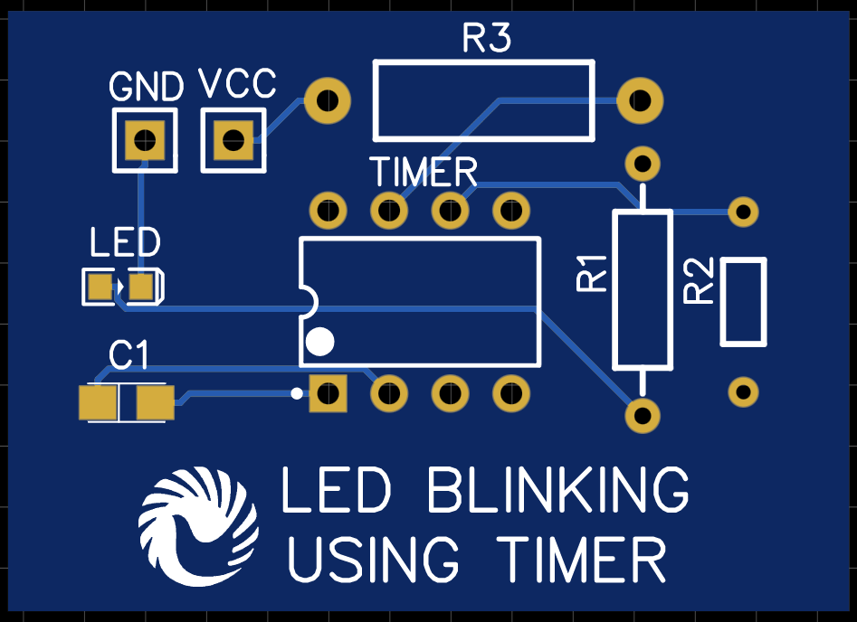

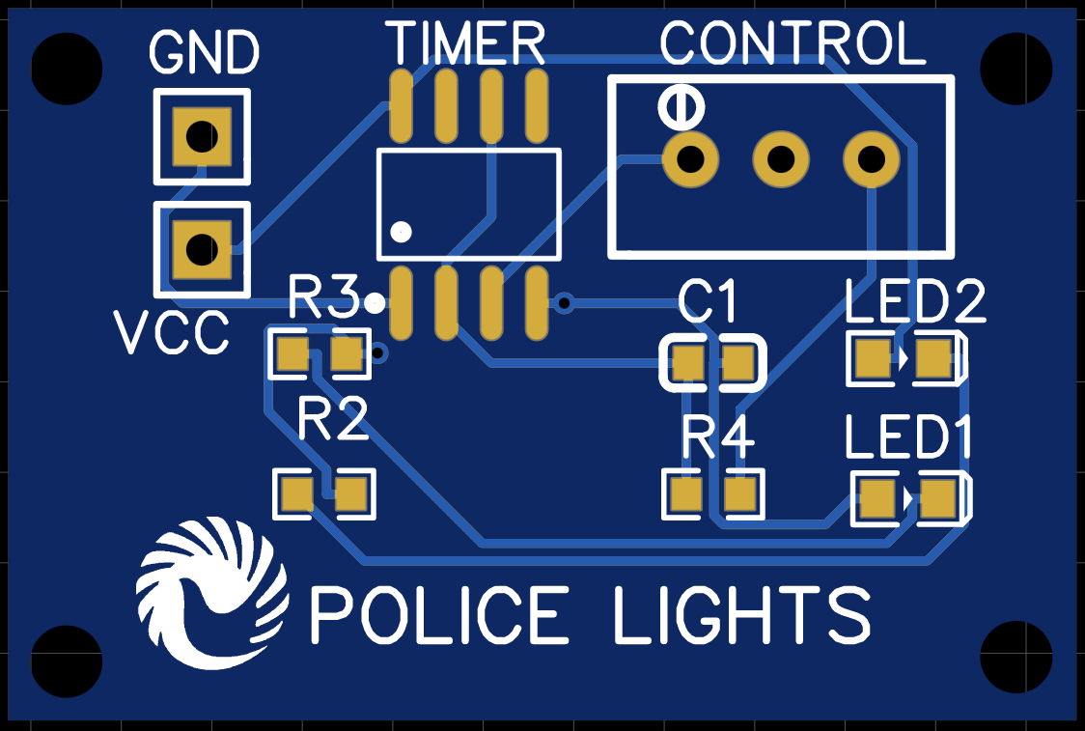

* We used EasyEDA software to design the circuit in PCB.
* Where we took components available according to the tinkercad circuit.
* The selection of components is done by the different parameters like space occupied, the max current flow, heat emission and absorption, etc.
* According to the design we implemented the and gave connections in PCB.
* We took max 2 layers of PCB to reduce the complexity and cost of the board.
* The connections are given by the software where it comes to complex connections.
* Later those connections are modified according to the circuit design and parameters like design placement and names of the component.

**Downloading Gerber file**

Gerber file is where it contains all information of the circuit build, PCB layout, thickness, no of layers, ports, holes, color, etc. Downloading gerber file is easy. Just go to file and select export where you can see gerber file and you can easily download and upload where ever you want.

**Appendix**